**Question 1**

create table ayush_157482(name varchar(30));

insert into ayush_157482 values('WARE HOUSE');

select substr(name,1,4) from ayush_157482;

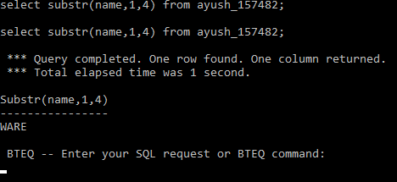

**Question2**

select current_date, add_months(current_date,+37);

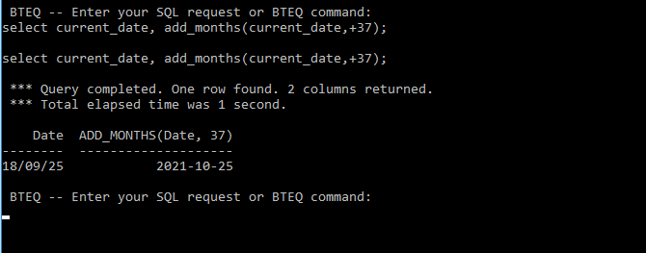

**Question 3**

create macro emp_157482(invalue varchar(30)) as (select employee_name from employee_157482 where employee_location=:invalue;);

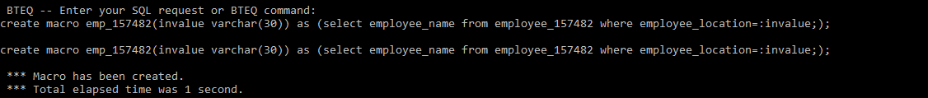

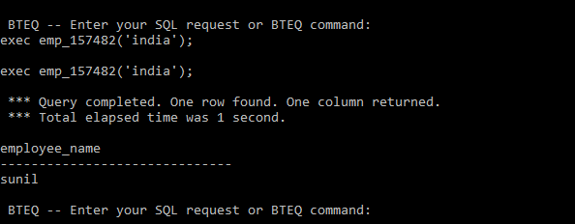

**Question4**

create multiset table employee_157482(employee_name varchar(30),employee_location varchar(30));

insert into employee_157482 values('joe','new york');

insert into employee_157482 values('sunil','india');

insert into employee_157482 values('alex','russia');

insert into employee_157482 values('albert','canada');

insert into employee_157482 values('jack','new york');

insert into employee_157482 values('alex','russia');

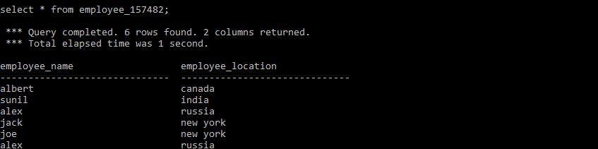

SELECT employee_location from employee_157482 GROUP BY employee_location;

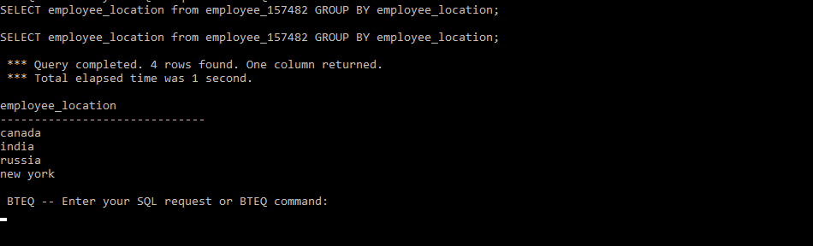

**Question5**

SELECT A.NAME, A.PHONE_NUM, B.USER_DATE FROM USER1 A INNER JOIN USERHISTORY B ON A.USER_ID=B.USER_ID WHERE CURRENT_DATE-B.USER_DATE<30 AND B.ACTION='logged_on' AND B.USER_DATE IN ( SELECT MAX(USER_DATE) FROM USERHISTORY WHERE USER_ID =A.USER_ID);

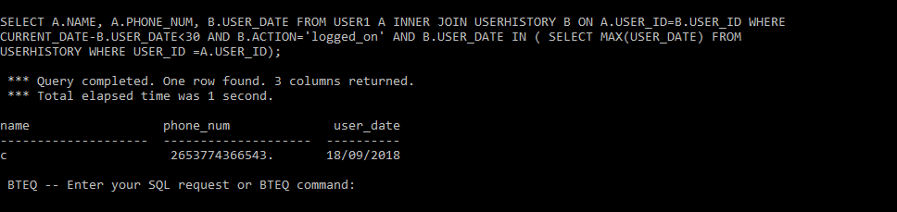

**Question6**

1. SELECT DISTINCT(S.NAME) FROM SALESPERSON_157482 AS S,CUSTOMER_157482 AS C,ORDERS_157482 AS O WHERE S.ID = O.SALESPERSON_ID AND O.CUST_ID = C.ID AND C.NAME ='Samsonic';

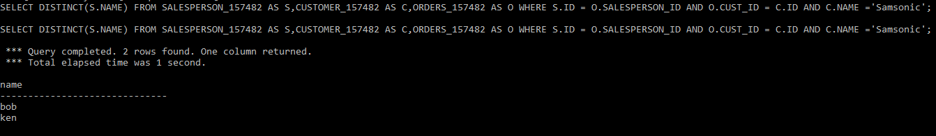

1. SELECT DISTINCT(S.NAME) FROM SALESPERSON_157482 AS S,CUSTOMER_157482 AS C,ORDERS_157482 AS O WHERE S.ID = O.SALESPERSON_ID AND C.ID = O.CUST_ID AND S.ID NOT IN (SELECT S.ID FROM SALESPERSON_157482 AS S,CUSTOMER_157482 AS C,ORDERS_157482 AS O WHERE S.ID = O.SALESPERSON_ID AND C.ID = O.CUST_ID AND C.NAME = 'SAMSONIC');

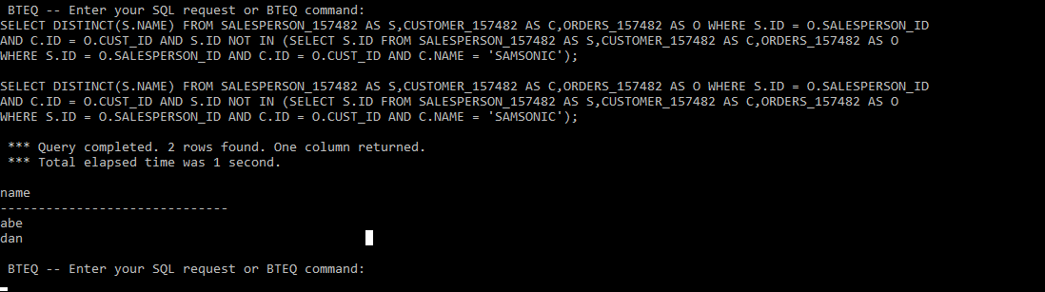

1. SELECT S.NAME FROM SALESPERSON_157482 S,ORDERS_157482 O WHERE S.ID=O.SALESPERSON_ID GROUP BY NAME HAVING COUNT(NAME)>=2;

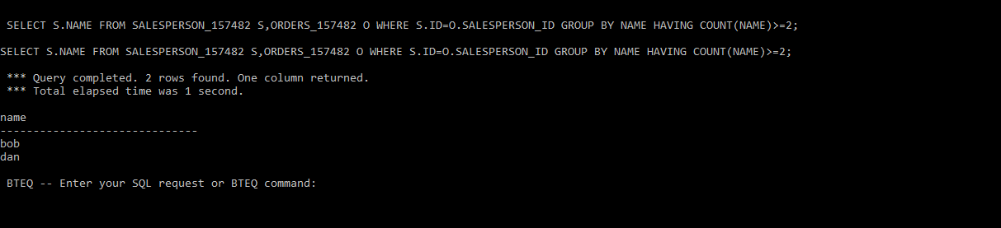

1. CREATE TABLE highAchiever_157482 (name varchar(20),age number(4));

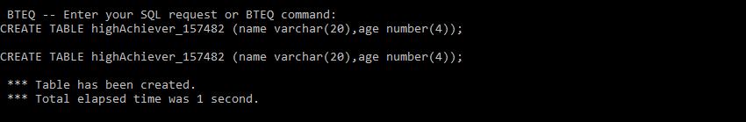

insert into highachiever_157482(name,age) select name,age from salesperson_157482 where salary>100000;

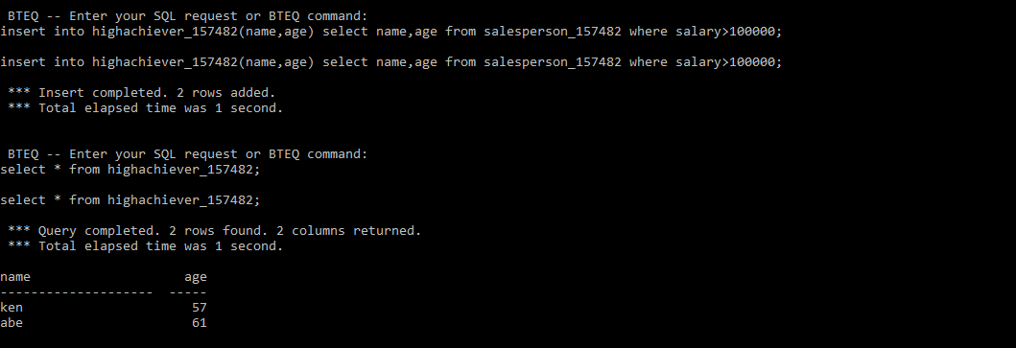

**Question 7.**

File name:-first.FL

LOGON 10.58.0.66/td_user20,td_user20;

DATABASE TD_BIM_FR_TRNG_DB;

BEGIN LOADING fastload_157482

ERRORFILES mittal_114, mittal_127

CHECKPOINT 10;

SET RECORD VARTEXT ",";

DEFINE

in_Empno (VARCHAR(20)) ,

in_Deptno (VARCHAR(20)) ,

in_First_name (VARCHAR(20)) ,

in_Last_name (VARCHAR(20)) ,

in_salary (VARCHAR(20)) ,

FILE=EmpUs.txt;

INSERT INTO fastload_157482 VALUES(

:in_Empno ,

:in_Deptno,

:in_First_name ,

:in_Last_name ,

:in_salary );

LOGOFF;

Filename :-second.fl

LOGON 10.58.0.66/td_user20,td_user20;

DATABASE TD_BIM_FR_TRNG_DB;

BEGIN LOADING fastload_157482

ERRORFILES mittal_114, mittal_127

CHECKPOINT 10;

SET RECORD VARTEXT ",";

DEFINE

in_Empno (VARCHAR(20)) ,

in_Deptno (VARCHAR(20)) ,

in_First_name (VARCHAR(20)) ,

in_Last_name (VARCHAR(20)) ,

in_salary (VARCHAR(20)) ,

FILE=EmpIntl.txt;

INSERT INTO fastload_157482 VALUES(

:in_Empno ,

:in_Deptno,

:in_First_name ,

:in_Last_name ,

:in_salary );

END LOADING;

LOGOFF;

